Geogebra Lesson:
Functions, Derivatives, and Graphing
Grades 9-12

Introduction:

Definition:
In mathematics, a function is a relation between a set of inputs and a set of permissible outputs with the property that each input is related to exactly one output.
Derivative - The rate at which one variable quantity changes with respect to another.
For a function y = f(x), the derivative at point (x,y) represents the limit of the gradient of a chord connecting two points on a curve as the distance between the points approaches zero. It is the slope of the tangent to the curve y = f(x) at that point, normally denoted by f´(x) or dy/dx.

Our Goal Today:
Creating a function and a graph of the derivative

- Enter in the function in the X^3 – 12X- 4
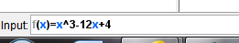

- We need to fix the screen to see our graph better.
  - Going to first center the graph by dragging it more to the center of the computer screen.
  - We now want to reconfigure the axes so we can see our graph better. Right click on the x-axis and change the setting to 1:10

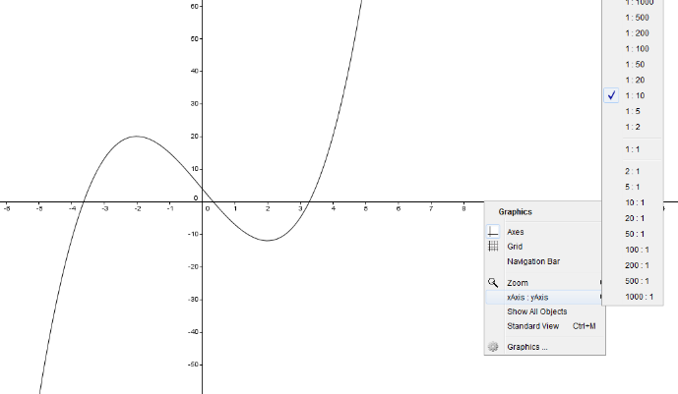

  - One more thing to do to see our graph better is zoom in click right on the middle of the graph. (2 clicks)

- Now we want to put a point on the graph and create a slider.
  - Click on the second to last option on the tool bar (a=2). Click anywhere in the white area. When the box appears we are leaving everything the same so you can hit apply.
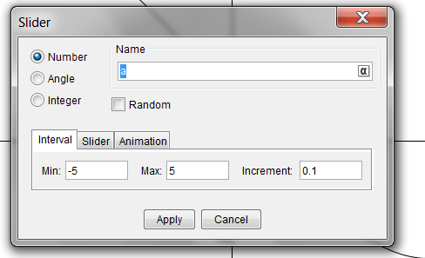
  - Now that we have our slider we need to click on move, then click back in the input box and type x=a 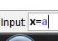. This will give us a vertical line that will move around every time we slide the slider.

- Next, we want to find the point of intersection of the vertical line and the polynomial function.
  - We need to click on the point tool, second option on the tool bar, hover over where the two intersect you will see both graphs being BOLD then click. We have created the point of intersection. Also if you click back on move, as you move the slider the point of intersection will also move.

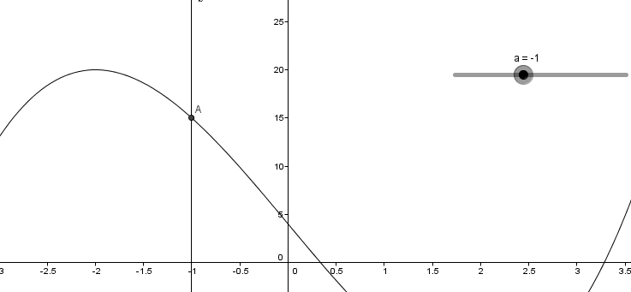

  - The vertical line is not necessary to we are going to get rid of it. By clicking on move then right clicking on the vertical line, click show object. The line will disappear. Even though the line is hidden you can still see the point move alone the curve you move the slider.
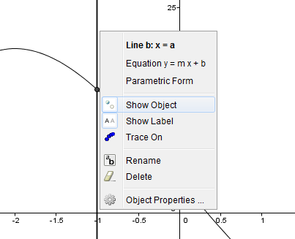

- Create the tangent line to the curve at this point a.
  - We need to click on the fourth option on the tool bar perpendicular line, click on the red down arrow, and click on tangents.
  - Once tangent is selected click on the point a, and the function curve. We have just created the tangent line to the curve at point a.
  - As you move the slider you see the tangent line at every point along this function curve.

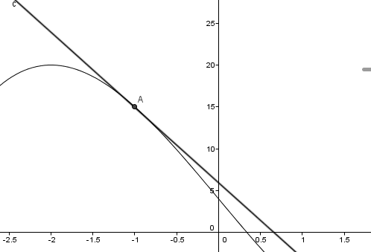

- We want to fine the Derivative of this which is the slope of the tangent line at that curve.
  - Find the slope by clicking the angel tool, down arrow, then look for the slope. Now hover over and click on the tangent line. Now we have the slope of the tangent line at point a.
  - We can notice the slope changing as we move tangent line alone the curve.
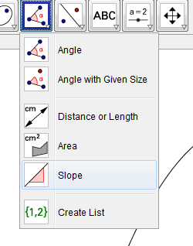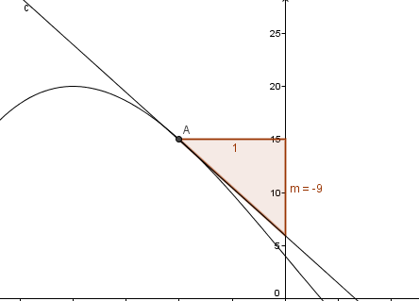

- Now we want to create a point that corresppnds to the x value of this point on the curve and the slope. X value and slope of the tangent line. X value is whatever a is, and the slope is m. (a and m) are the corrdints of the ordered pair we want to plot.
  - Go to input and type P=(a,m) [ p needs to be capitable]
  - Point P is corresponds to x value of the point at a, and the slope.

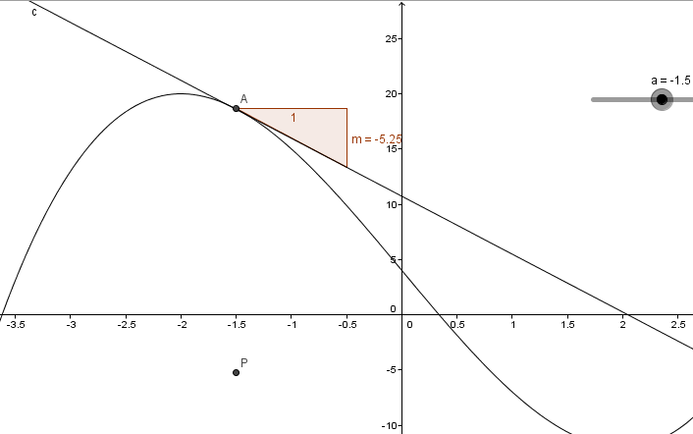
- To graph the derivative we need all the point values for the x values of the function and the slope. To see all the points show up we need to right click on point P and click trace on.
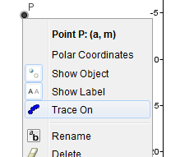

- Click on move, then move the slider back and forth. It’s tracing out a graph of the derivative of this function.
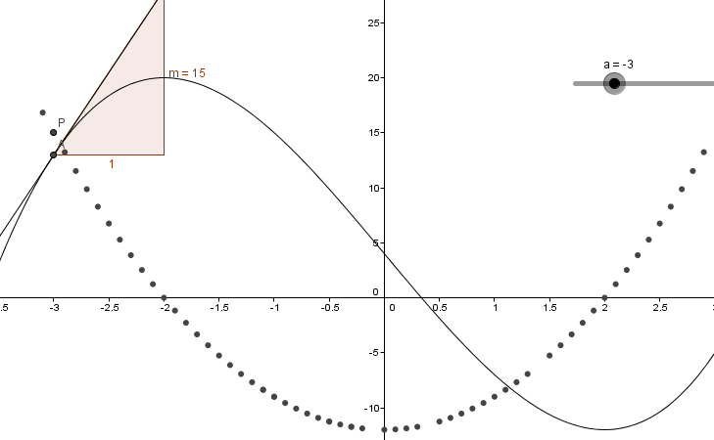
- Now we want to show the graph of the derivative.
  - Click in the input bar and type f ’(x) hit enter. It graphs the derivative of the function. Point P every point traces right along and corresponds exactly to that derivative curve. If you move point p you will see it tracing perfectly along the curve.

- Let’s make our graph look nicer.
  - Go to the option on the tool bar where you created the slider. We want to add a check box. We want to show and hide the derivative graph. Caption type show f’(x). Select the down arrow, select f’ option. It allows you to show and hide the derivative graph.

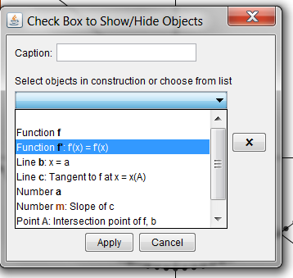

- Now we want to remove the slope triangle. Right click on the slope triangle then click on show object to hide the slope triangle.
- Change the color of the function curve. Right click on the curve click object properties, click to change color, and on style change thickness of the line.
- Tangent line right click object properties. Change the solid line to dotted, make it thick, and change the color.
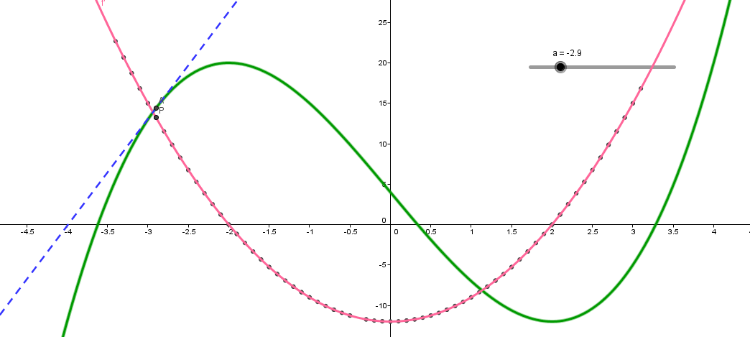

Extra Problems:

- Use the power rule to check the derivative of the graph we plotted.

- Use the steps just learned to create a function and a graph the derivative of:

F(x) = X^4 + 8x -5

